PDF Merging with Business Central
To merge PDFs in Business Central, you can leverage the built-in report or Temp Blob functionality, along with external libraries for the merging process. Below is an outline of the steps you can follow:

Steps to Merge PDFs in Business Central:
- Prepare Your PDFs:
Ensure the PDFs you want to merge are available. These PDFs can either be stored as document attachments or generated dynamically via reports. For this approach, we use a customized PDF viewer instead of document attachments to access the PDFs.
- Export PDFs to a TempBlob:
Save the content of the PDFs to a TempBlob, which can be achieved using the TempBlob codeunit or similar functionality in AL.
- Use Control Add-in to Merge PDFs:
Although Business Central does not provide native support for merging PDFs, you can integrate external libraries such as a JavaScript PDF library within a control add-in to perform the merging operation.
- Custom AL Code to Merge PDFs:
  - Read the PDF Files: Use streams or the TempBlob to read the content of each PDF.
  - Merge the Content: Implement custom logic to combine the PDFs into a single document.
- Save and Output the Merged PDF:
After merging the PDFs, save the result as a new TempBlob and export it to a file for further use or distribution.
This process allows you to seamlessly merge multiple PDFs within the Business Central environment, providing a flexible solution for PDF handling.
The following scripts were utilized
Created Controladdin by using scripts
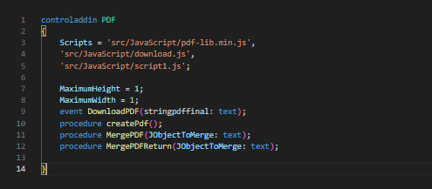
Added the created contoladdin in page
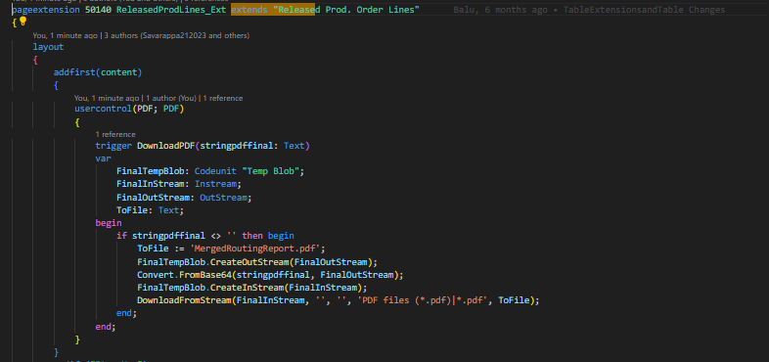

Created one action for Merging PDF to Report
